Help from cli

- man command

There are 9 catagories in the man command , each categories have different role.

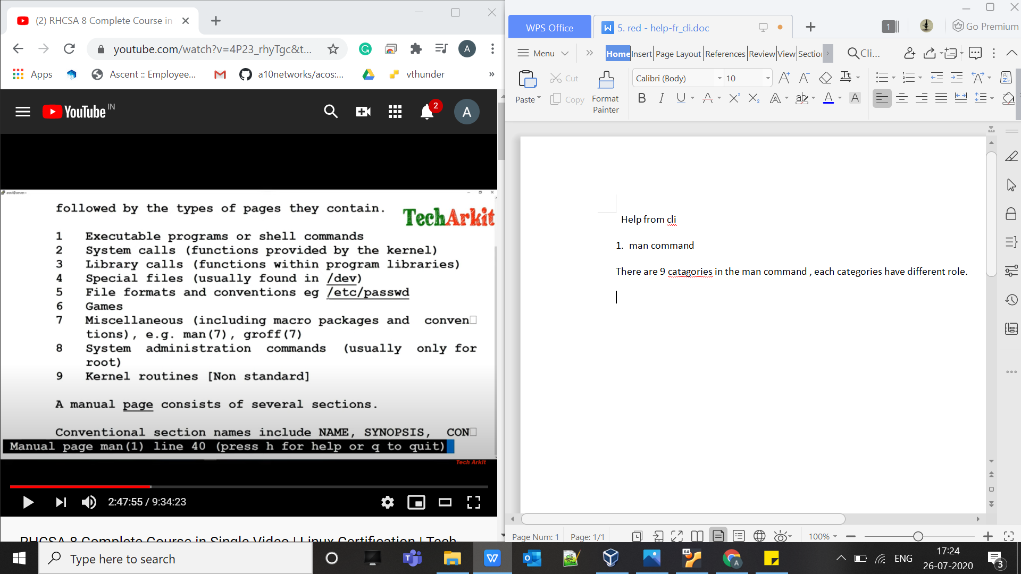

To select categorizes

$ man -s <catagory number> <topic name>
Eg :- $ man -s 5 passwd

SSH server And Client Configuration

$rpm -ga | grep openSSH => this will search about install pakages

Vim /etc/ssh/sshd_config => here all the configuration about shh stores.
Means port, allowed address, keys and all that.

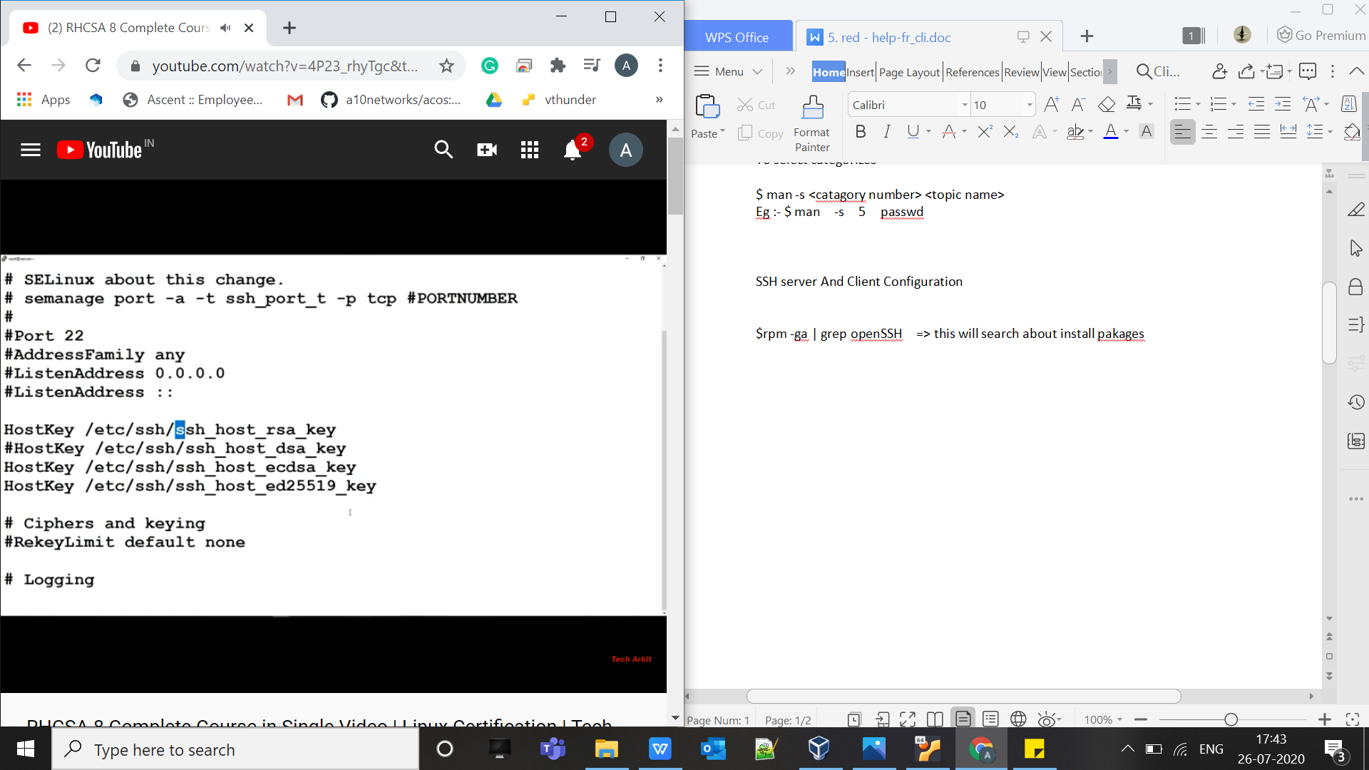

Here all key work same , but there authentication method is different.b
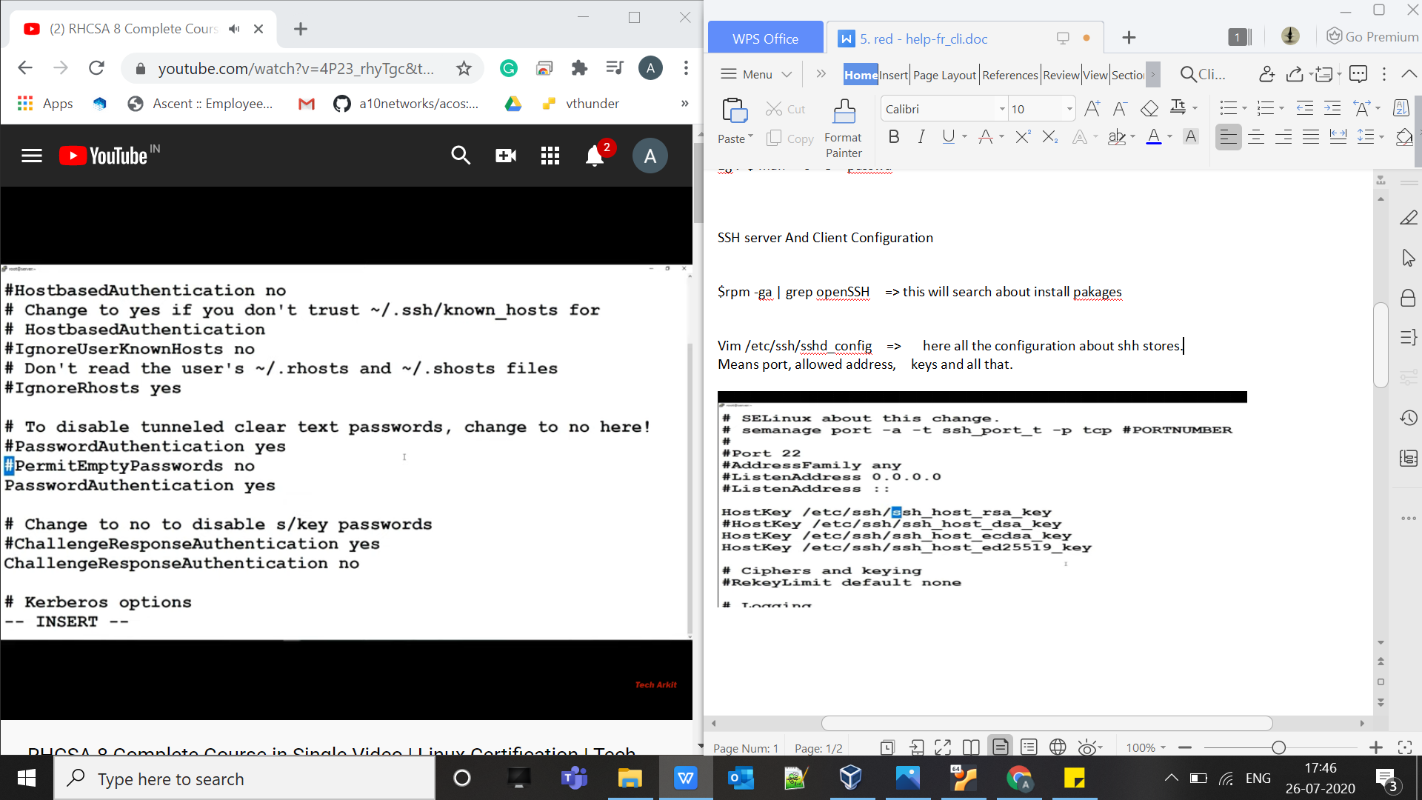

Here we can set passwd authentication and all other stuff ,

Just comment and uncommet to make changes.

To add user group :-
$ groupadd <group-name>

To add user in the user group:-
$ usermod -aG <group-name> <user-name>

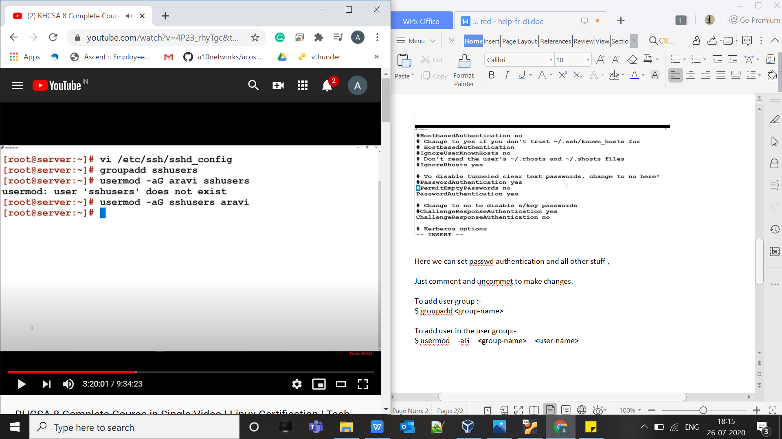

To change the password of user :-

$ passwd user1
Then enter password.

To see detail about user is :-
$ id <user-name>
This will show , uid, gid, groups

KEY authentication :-

For ssh key based authentication we need create ssh key
Go to home directory and command :-

$ ssh-keygen -t rsa => by this we will create a key , rsa/dsa/other key pair

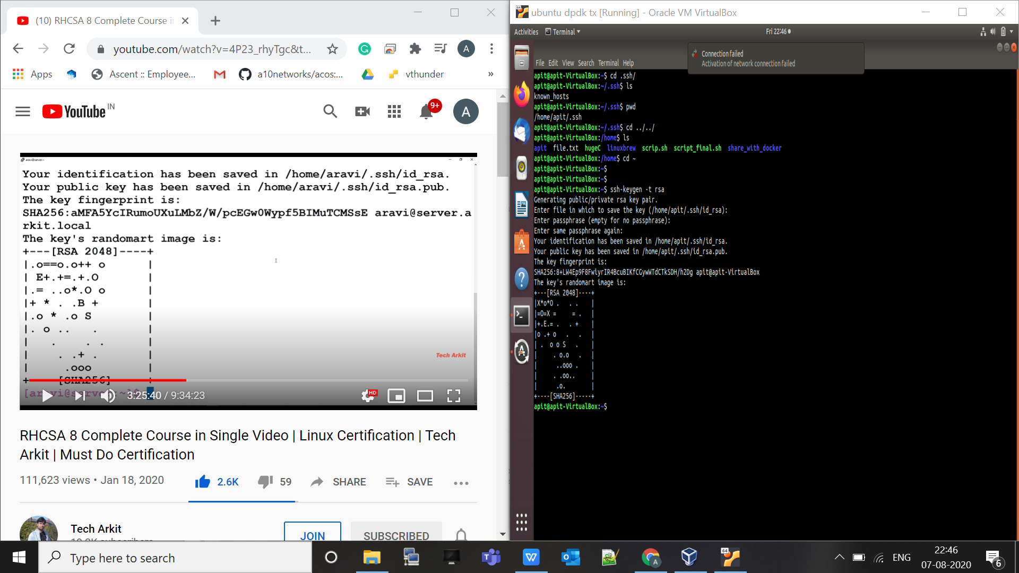

Now do ~$ cd .ssh => here you will find public and private key.

Then do $ cat id_rsa.pub => to see public key

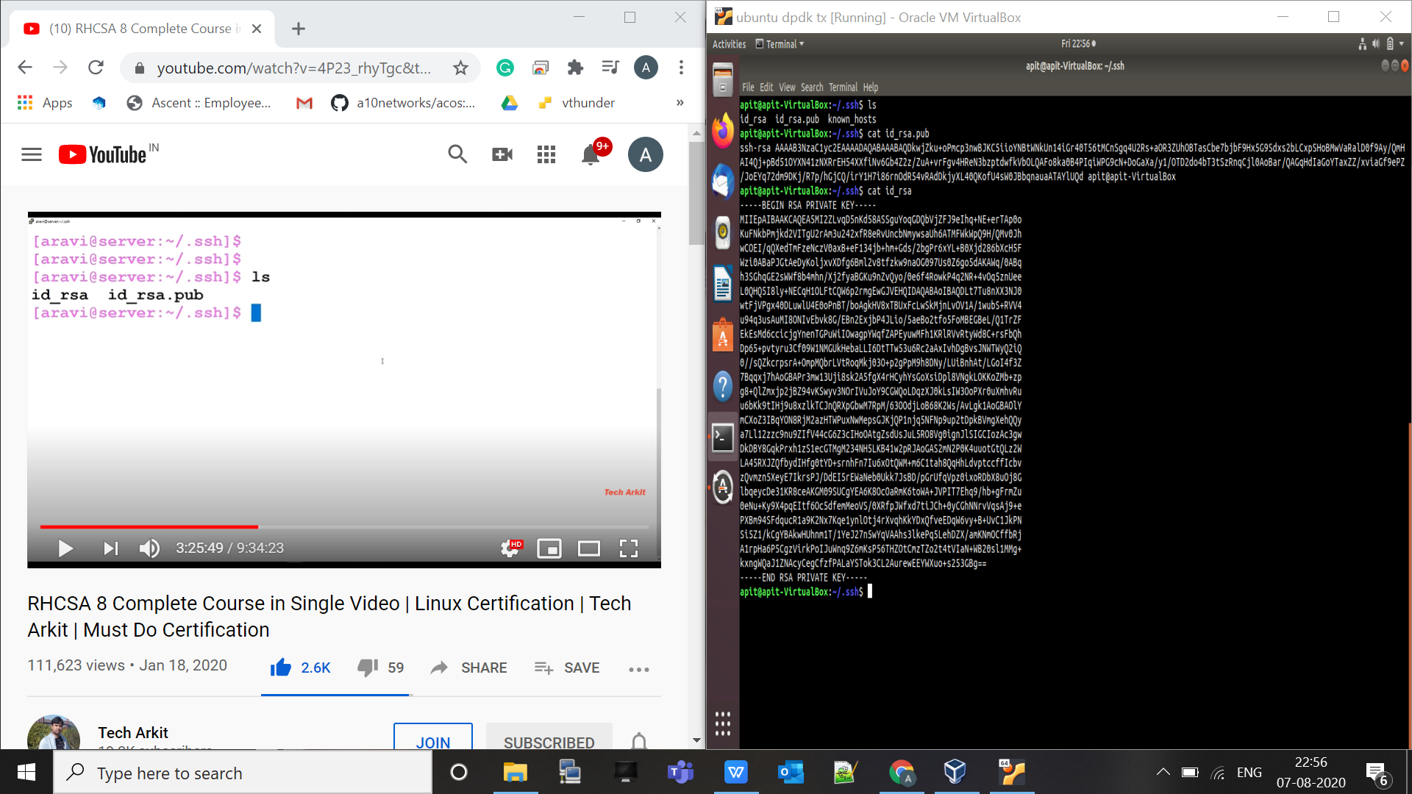

Now we need to copy that public key to remote server , to create authentication

To copy to remote server we need to do

$ ssh-copy-id server@192.168.2.140

Then go to the remote server and do $ cd .ssh this will you can see your file is being copy under file name “authorized_keys”

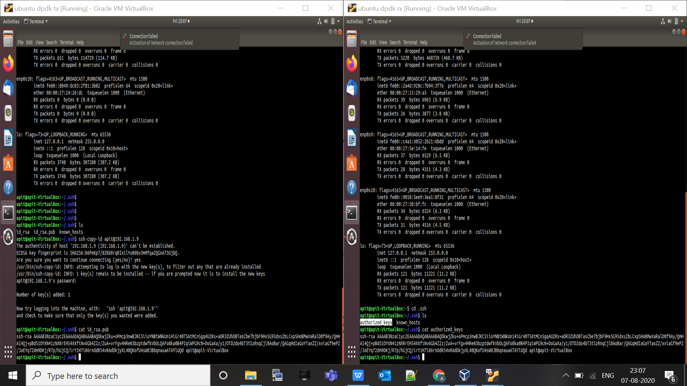

Now we can do ssh without password.

Just do $ ssh username@ip it will not ask for password.

If you want to do some command on remote server , without getting login we need to just type

$ ssh username@ip <command like ls / update/hostname/mkdir /other command>

